Blog
Capturing the moment:
My Experience with Casual Photography

Personal insight
21st Feb | Rahib Kibria Choudhury

It is obvious that photography is a well-loved hobby and maybe even a profession for a lot of people. I have friends who are making a living out of this and are very happy doing what they enjoy. I personally never delved deep into photography. It has always been a means of saving scenes so that I may revisit it later and maybe even share them with my friends and family through social media.

All the pictures I have taken so far have been through my mobile phone which I bought around 4 years ago. It is a xiaomi poco f1 which was considered one of the best mid-range phones at the time in overall performance. It has made me realize that I don’t necessarily need a DSLR for really good pictures. I have been content with the pictures and still use the same phone to this day.
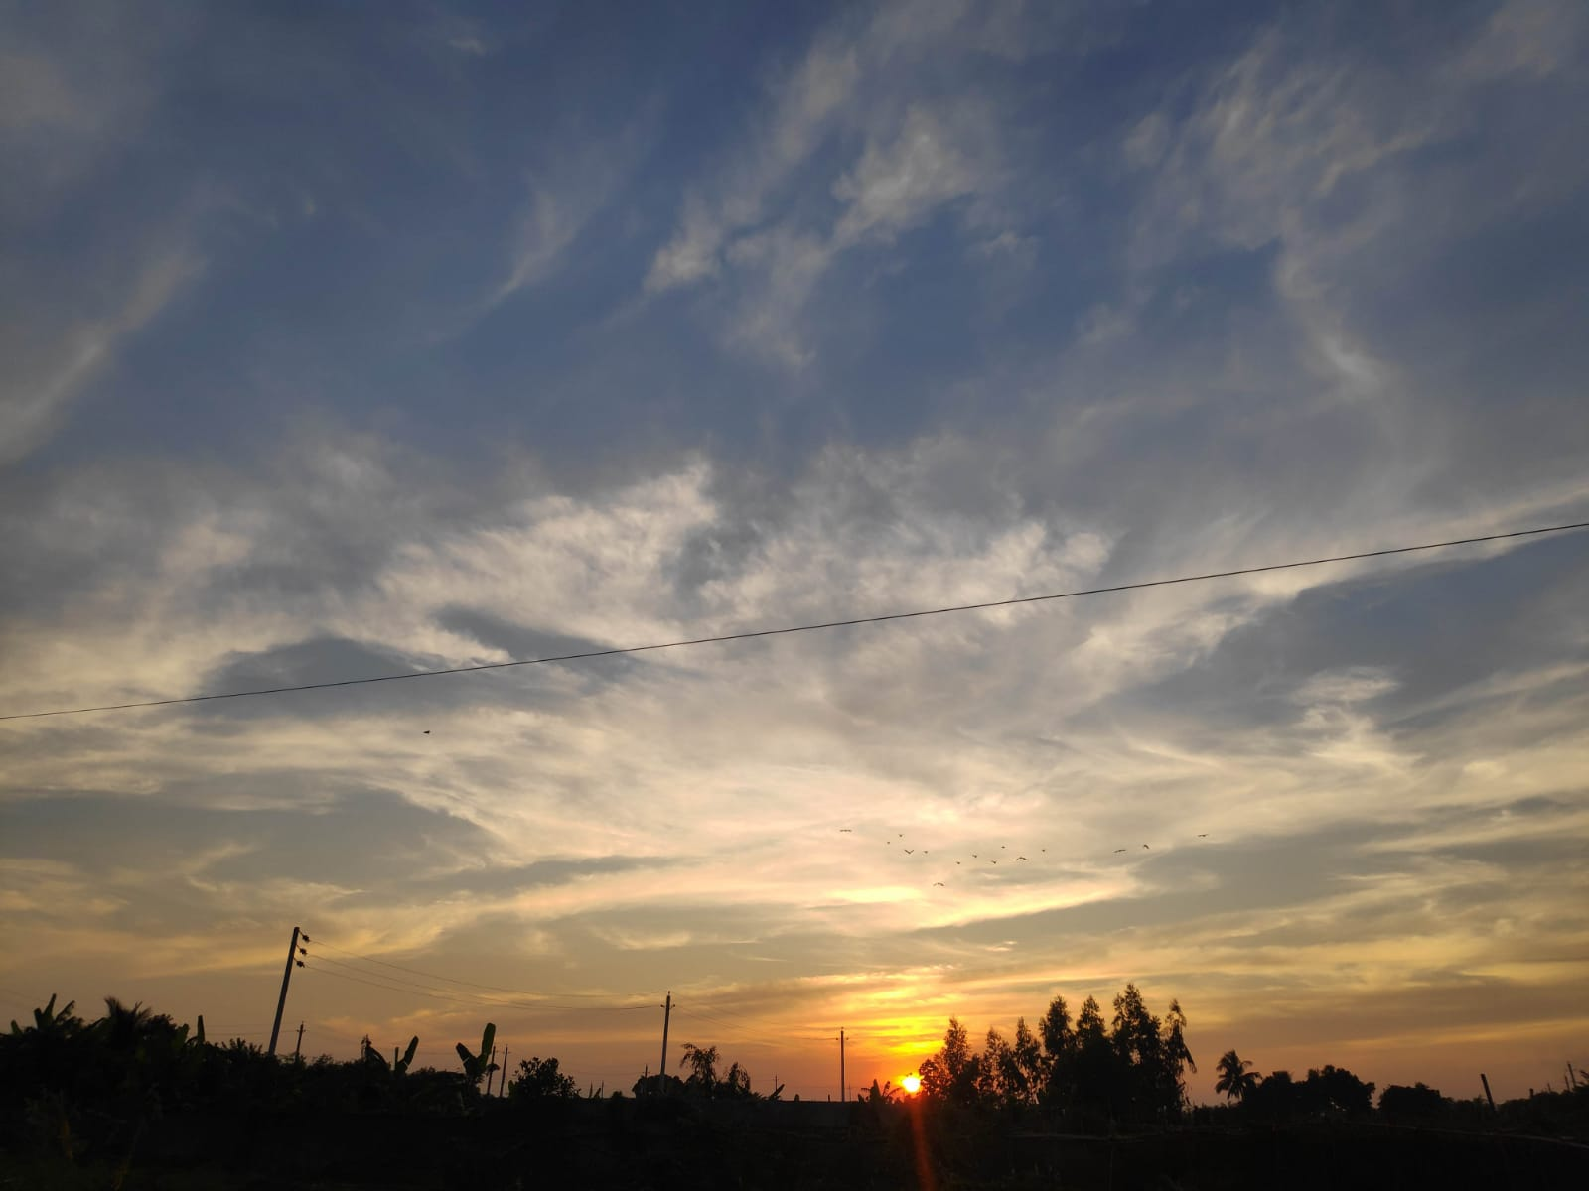
As for software for editing the picture, not much is needed from my experience. The default editors in my phone ended up meeting my needs considering my pictures just needed exposure, brightness or sharpness adjustments from time to time.

I didn’t used to go out much outside of my classes after the pandemic hit unless my mother forced me to go out with her. We would end up going near Diabari or 300 feet road since those are my mother’s go-to spots just to enjoy the environment, take pictures and eat out.

I didn’t find the trips amusing at first though. As I had gotten used to an unhealthy lifestyle which consisted of eating, sleeping, studying and talking to friends through a computer screen. I’m sure I’m not the only one who got sucked into this predicament due to the pandemic. After a while, the fact that my mother wanted something about my present routine to change through these trips became plain as day to me.

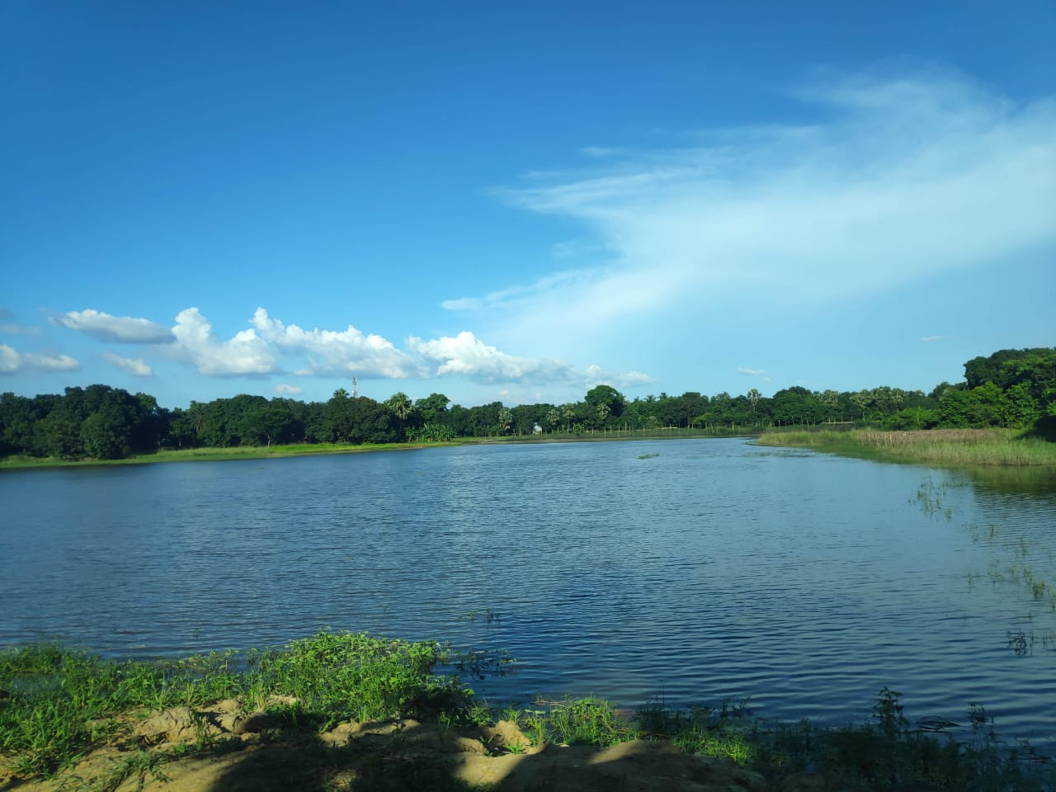

At some point in these trips I ended up being fond of sunset and scenery pictures. Something about the sun gleaming as it sets, the harmony in the ripples of the flowing rivers and the surrounding trees dancing to the orchestra of winds blowing I found awe-inspiring.
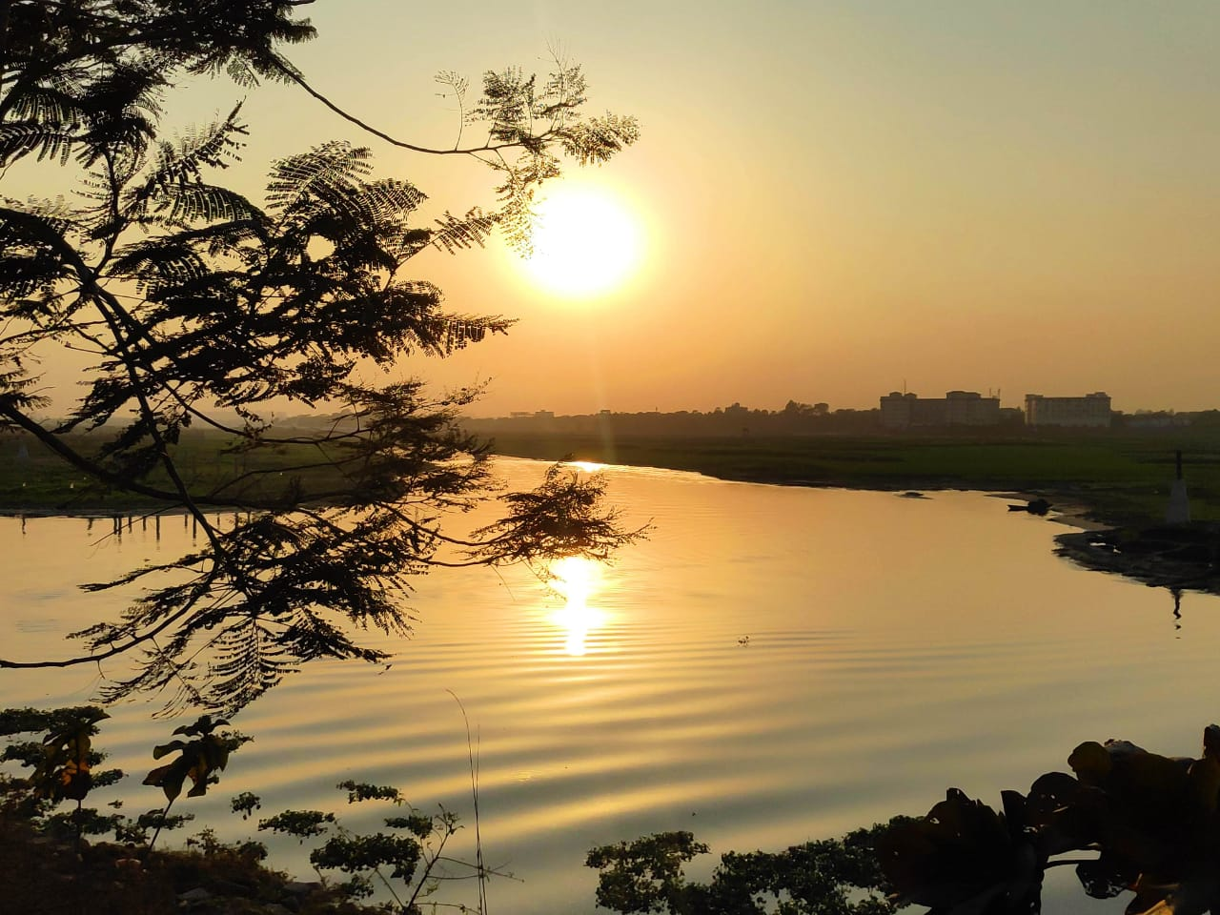

As the area is still more akin to a rural area with plenty of lakes/ponds and fauna in the process of being modernized, the visits end up feeling really enjoyable. Anyone would feel reinvigorated if they visit such a place after being cooped up in a room surrounded by nothing but more buildings with minimal breathing space in between.

Sometimes I recall certain things through pictures I may have taken as a point of reference. For example, my last year’s birthday where we went to an area near diabari where they serve the most mouth-watering rasmalai I’ve ever eaten and I got to witness a scene I still remember even though many months have passed.

It was a glorious sunset with thick and thin masses of clouds partially painted in gold with rays of the sun protruding through the clouds and the flowing river reflecting the sunlight almost like a red carpet for the sun. On top of that, one of the clouds resembles the shape of a heart.
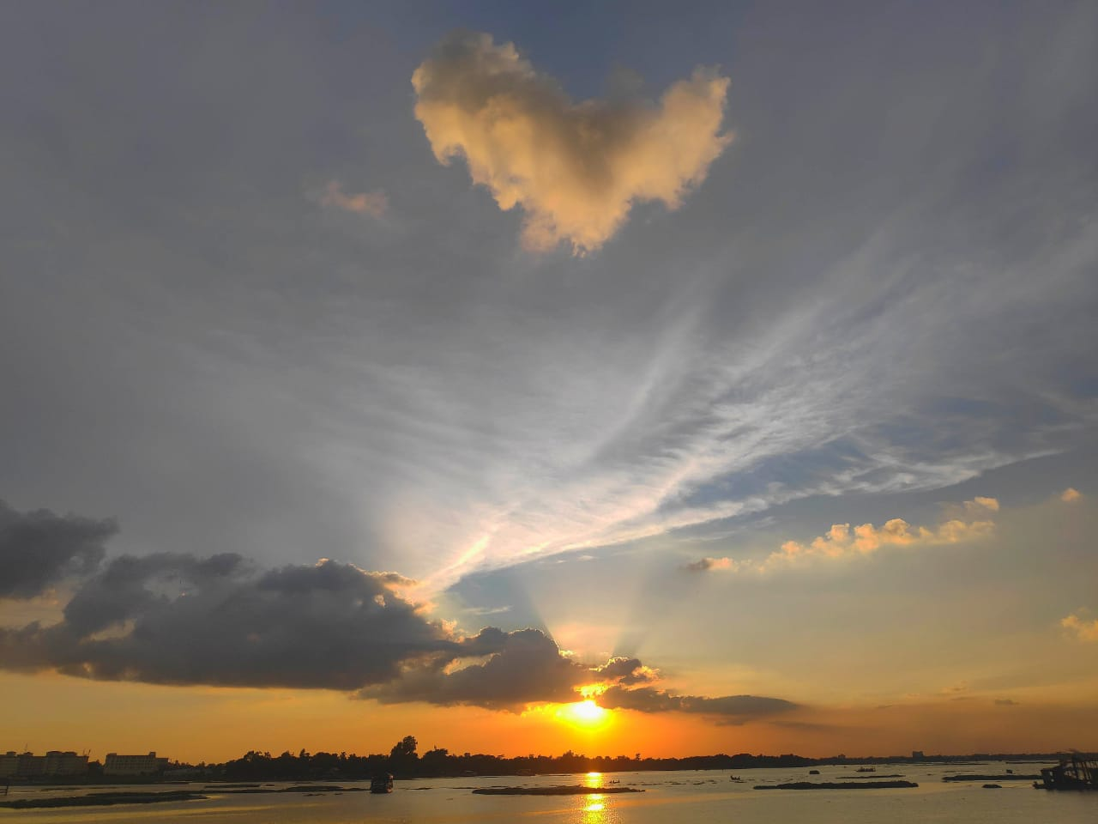

This image ended up being my favorite to date and even my wallpaper for a few months. I also gave my mother a hard-back phone case with this picture printed on it which she happily accepted, appreciating the symbolism of me giving her a birthday gift that connected to my birthday through a picture.

As of now I look forward to our outings though less frequent since university classes have begun. These trips have granted me a new-found appreciation for the world around me and put me in a mindset far cry from what it was right after the lockdown.

To conclude, I would like to encourage others to try casual photography too as the requirements aren’t hard to meet as seen through some of the shots I was able to capture through my phone. I’m sure many will come to relate to this feeling of appreciation for the world we live in since we have lived through a long time of solitude that tends to cloud one’s vision of the big picture.

